BUS 440 Project 1
Fall 2025

Use Case:
Suppose you are hired to create a database for the annual CrossFit National Competition. In this project, you will design and build a relational database to hold data about the male athletes, countries represented, division, gyms and scores. See the following website to get more information on the competition: History of the CrossFit National Champions
Instructions:
- Download and open the .csv file with data on Moodle from the 2019 CrossFit National Competition. Scrutinize the data then write the business rules for the use case.

- Every record must have a unique id
- Rank must be a positive integer between 1 and the total number of competitors for that workout
- Competitorid must not be null because each performance must be linked to a valid athlete
- Breakdown, scoredisplay, and time fields must not be empty
- Breakdown must reflect the maximum points awarded in that specific workout
- In one year, competitorid must participate in all the workouts defined for that year’s division unless the competitor did not finish
- Eventtotalpoints can determine the overall standings because it is a calculated field
- Each workoutid defines the valid range of lanes, heats, and max points for consistency validation

2. a. Write the functional dependencies below.
Competitorid → height, weight, affiliateid, status, bibid, firstname, lastname, gender, age, overallrank, overallscore, division, countryoforigincode
Affiliateid → affiliatename
Countryoforigincode → countryfororiginname, countrypopulation
workoutIDfordivision, competitorid, year → rank, points, scoredisplay, time, workoutrank, breakdown, lane, heat

b. Next, notice and validate the two relational schemas based on themes (shown below).
SCORE (workoutIDforDivision, breakdown, lane, rank, heat, Points, scoredisplay, time, workoutrank, competitorid, Year)
COMPETITOR (height, affiliateid, countryoforiginname, weight, affiliatename, status, bibid, competitorid, firstname, gender, age, lastname, countryoforigincode, overallrank, overallscore, division, countrypopulation)

3. For each of the relational schemas shown in step 2b, normalize the data to 3NF, assuming that each theme data is a relation. Show your work for each step (1NF, 2NF, and 3NF) below. Do not use any surrogate PKs in this step.
1NF: Find the PK. Underline and bold it for each relation representing the two themes of data.
SCORE (workoutIDforDivision, breakdown, lane, rank, heat, Points, scoredisplay, time, workoutrank, competitorid, Year)
COMPETITOR (height, affiliateid, countryoforigeinname, weight, affiliatename, status, bibid, competitorid, firstname, gender, age, lastname, countryoforigincode, overallrank, overallscore, division, countrypopulation)
2NF: Remove any partial dependencies.
SCORE(workoutIDforDivision, breakdown, lane, heat, competitorid, year, rank, points, scoredisplay, time, workoutrank)
COMPETITOR (height, affiliateid, countryoforiginname, weight, affiliatename, status, bibid, competitorid, firstname, gender, age, lastname, countryoforigincode, overallrank, overallscore, division, countrypopulation)

3NF: Remove transitive dependencies.
SCORE(workoutIDforDivision, breakdown, lane, heat, competitorid, year, scoredisplay, time, workoutrank, rank, points)
COMPETITOR (competitorid, height, affiliateid, weight, status, bibid, firstname, gender, age, lastname, countryoforigincode, overallrank, overallscore, division)
AFFILIATE(affiliateid, affiliatename)
COUNTRY(countryoforigincode, countryoforiginname, countrypopulation)

4. Copy your answer from 3NF and paste below. Then, add at least two improvements to the architectural design and show these improvements in the relational schema.
SCORE(Scoreid, competitorid, Year, workoutIDforDivison, heat, rank, Points, time, lane, scoredisplay, breakdown)
COMPETITOR (competitorid, height, affiliateid, weight, status, bibid, firstname, gender, age, lastname, countryoforigincode, overallrank, overallscore)
AFFILIATE(affiliateid, affiliatename, affliatestate)
COUNTRY(countryoforigincode, countryoforiginname, countrypopulation)

5. Create the ERD (or EER) for the architectural design of the database. Be sure to include all entities, relationships, keys, and cardinality. Draw the appropriate type of relationship, either identifying (solid line) or non-identifying (dashed line) based on your keys. Include a screenshot of the ERD below.
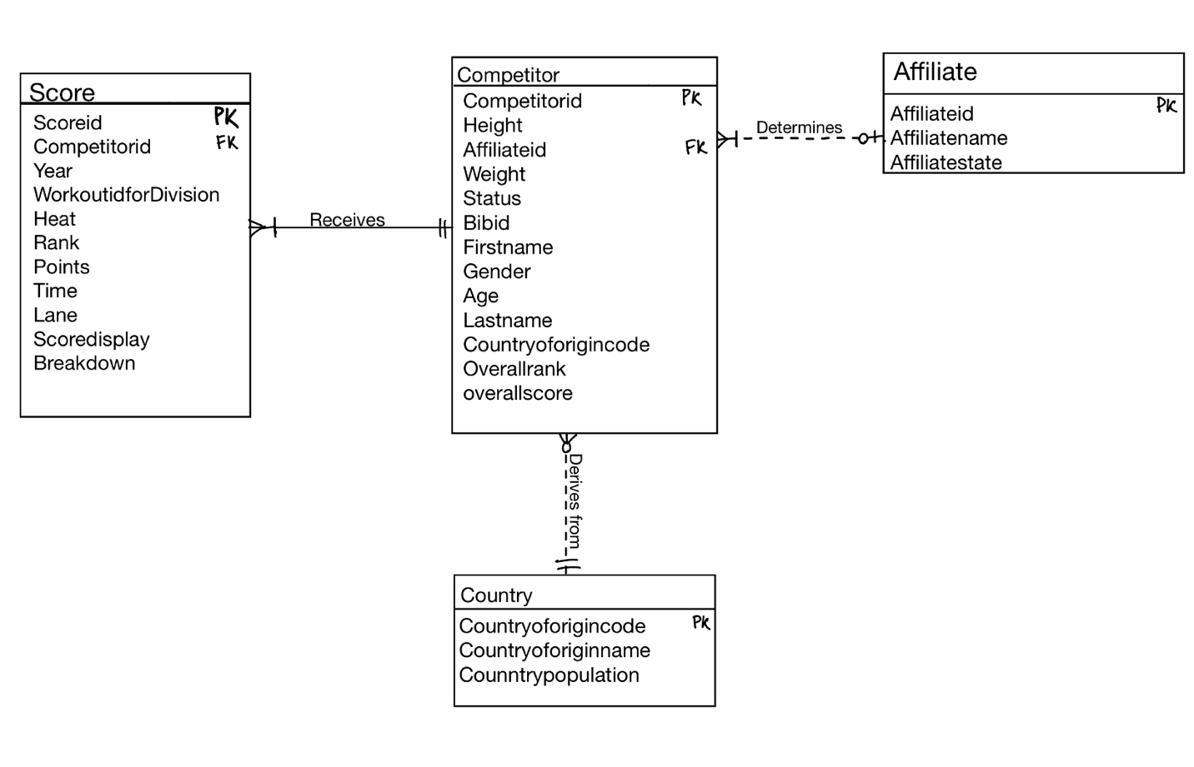
6. Create a new schema and populate the tables with data. To do so:
- Launch MySQL Workbench and create a new schema, crossfit, for the two sets of data shown in the Project 1 Data file.
- Populate the competitor data into a new table.
  - If you want to import the data, open Excel and separate the two datasets into two different .csv files before importing. Set the data type of all attributes as TEXT instead of INT, since some of the values or null or text based. Be sure to show the log to ensure no errors occur during the imports. Validate that all rows imported (203) before proceeding to the next step. (Note: If any rows did not import, you will need add those manually later.)
  - Instead of importing, you can alternatively use MrDataConverter.com to create DML code to populate the data. To do so:
    - Navigate to Mr. Data Converter
    - Change the bottom Output as: panel to MySQL.
    - Copy the data from Excel and paste it into the top panel.
    - Select the code in the bottom panel, copy the code, and paste it into a new query tab in MySQL Workbench.
    - In MySQL Workbench, change the table name to competitor in the script. Change the OverAllRank field to a data type of VARCHAR(5) instead of INT and also enclose any text-based values in the code with tickmarks.
    - Type and run the use statement.
    - Run the remainder of the code in the script.
- Use a similar approach to either populate the score data in a new table.
- If you import the data, be sure to set WorkOutRank and Rank as TEXT instead of INT, since some of the values or null or text based, and show the log to ensure no errors occur during the imports. Validate that all rows imported (4213) before proceeding to the next step. (Note: If any rows did not import, you will need add those manually. Further, importing these data may take some time to finish, depending on the speed of your machine, so initiate it and let it run at night or while you are doing something else.)
- Alternatively, if you use Mr. Data Convertor instead of importing, enclose Rank in back tick marks before running the code. Follow a similar approach as the one you followed for the competitor data above.

7. Open a new .sql script and save it as Project1YourName (where your name is your first and last name). Write SQL code using SELECT DISTINCT to populate the other necessary parent tables from your design with data. The “generic” syntax for this code is below. Be sure to create the empty tables first.
INSERT INTO target_table (column1, column2, ...)
SELECT DISTINCT column1, column2, ...
FROM source_table;
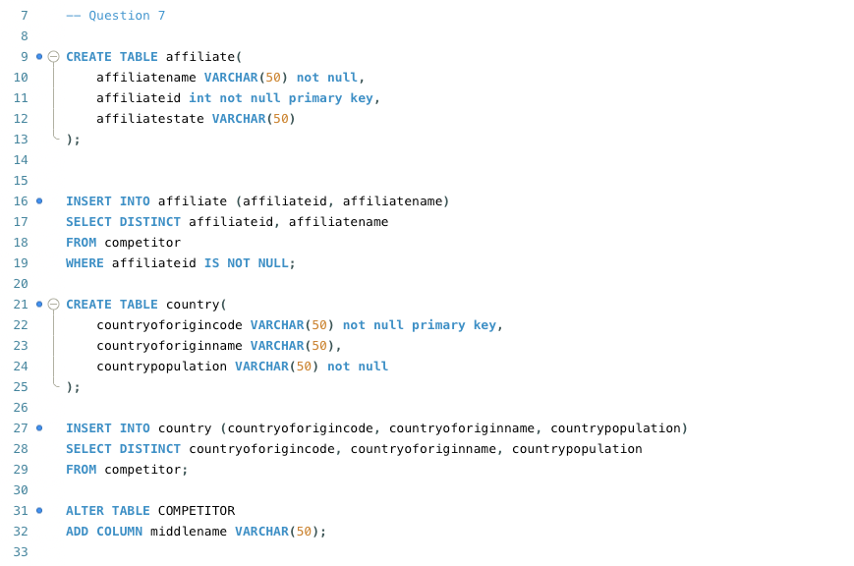

8. Be sure to create the PK for each table.
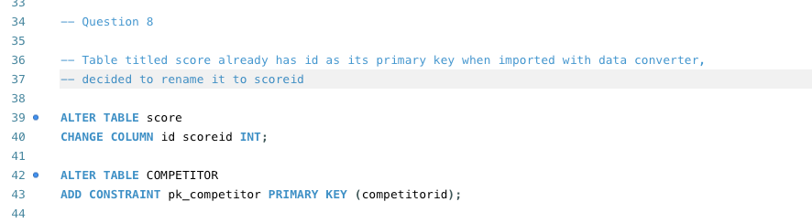

9. Write SQL code to create the necessary FKs for all tables in the schema.

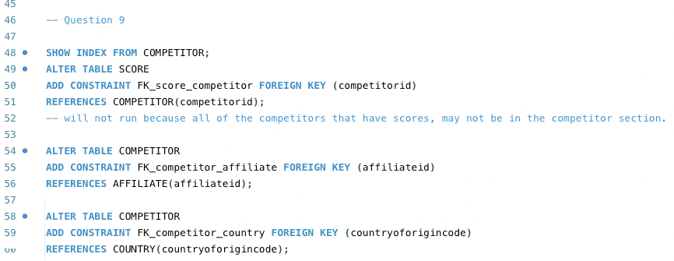

10. Write and execute SQL code to print out the data from each table.
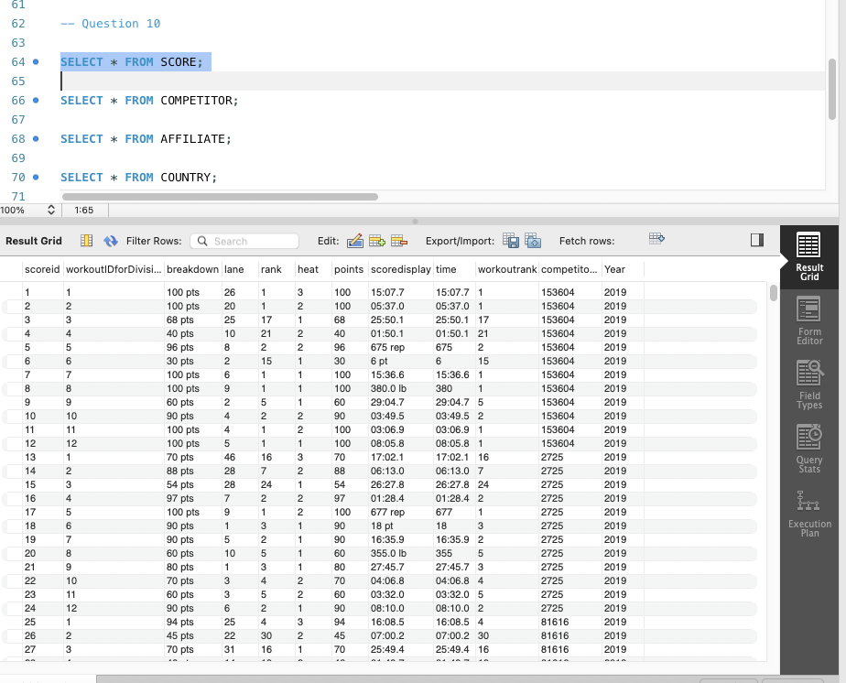

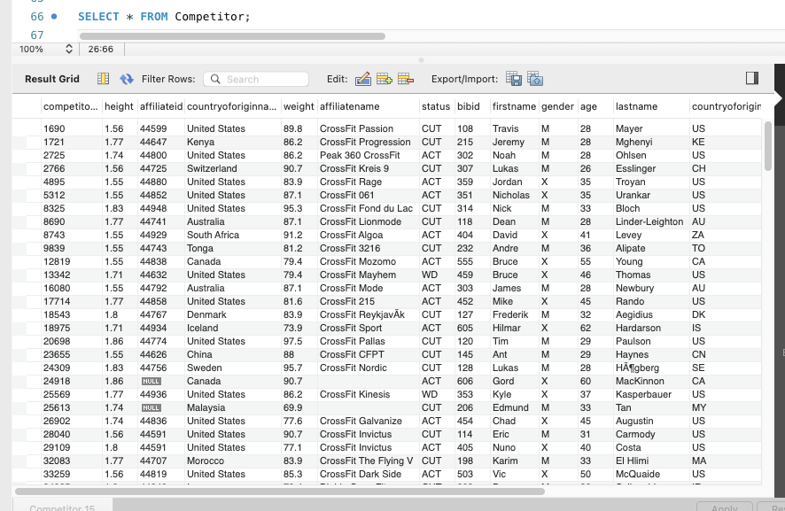
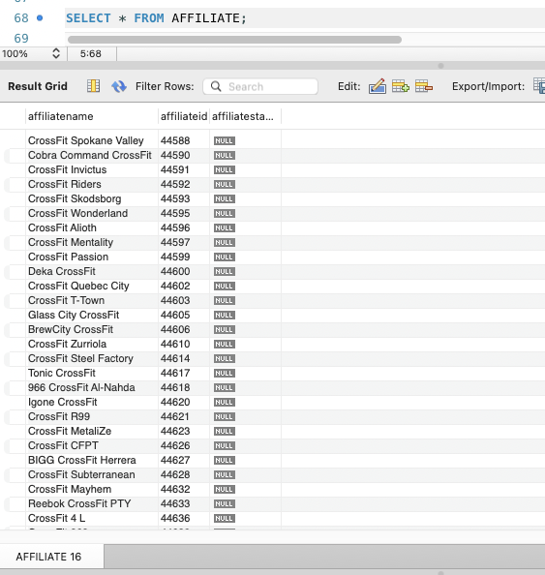

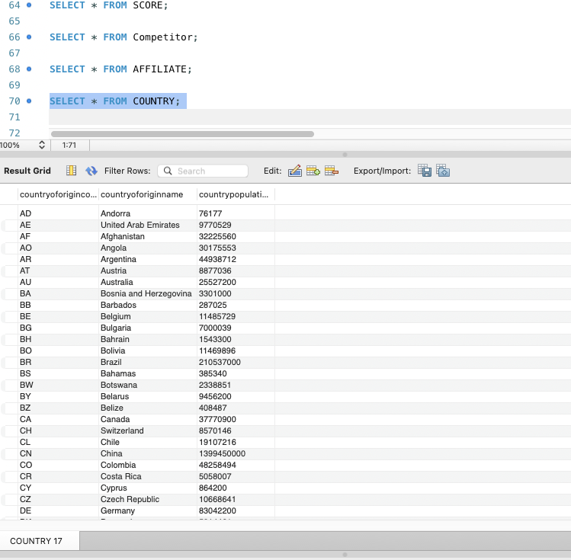
11. Write SQL code to answer the following questions:
- List the top competitor for 2019 with their country name in terms of overall rank. Validate your code. Does your result match the following screenshot from the website for the U.S.?
No, it does not match the provided screenshot(except for first answer); however, it does align with the actual Men’s leaderboard from the CrossFit Games (shown below). The screenshot provided does not represent the Men’s overall rankings.
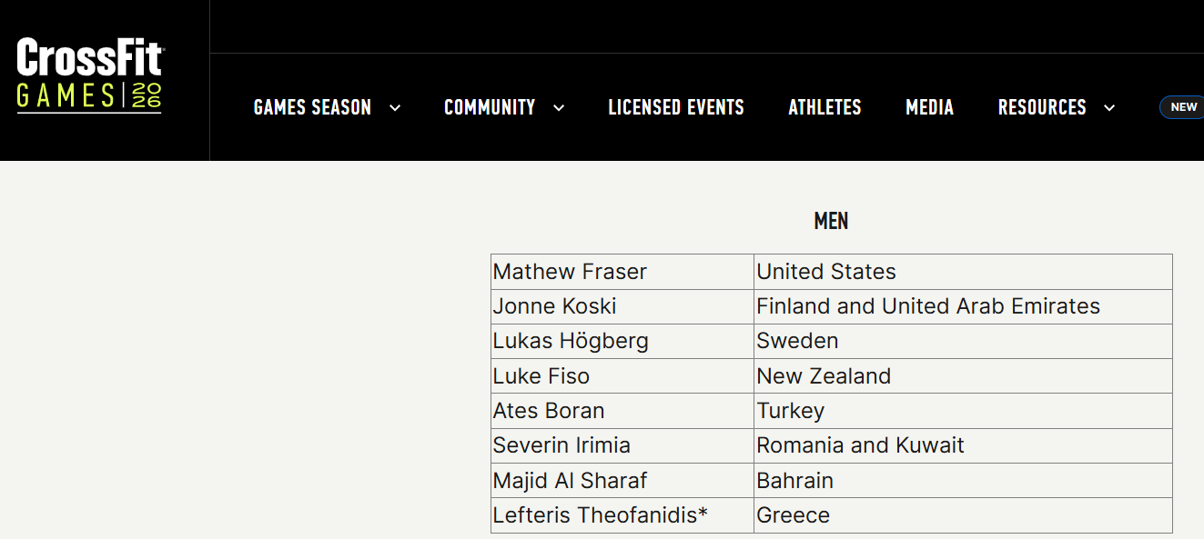
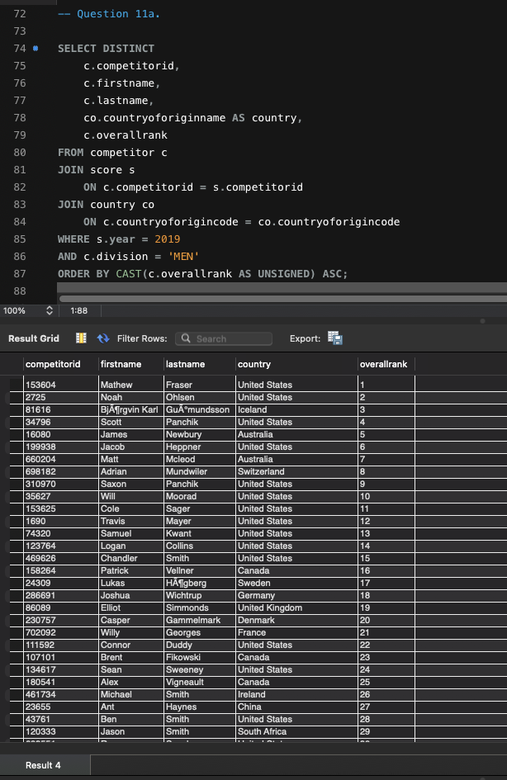
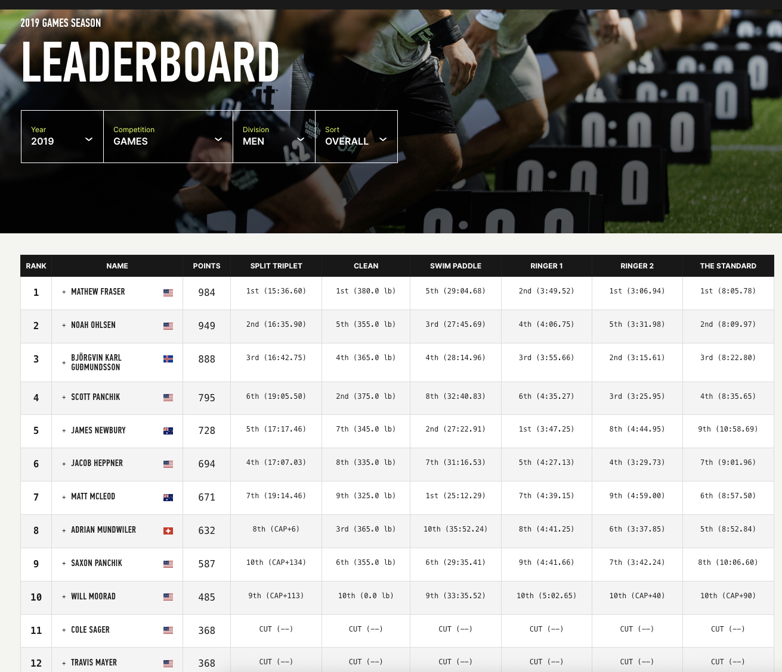

- Show the inactive competitors for 2019 (those who were cut or withdrew).
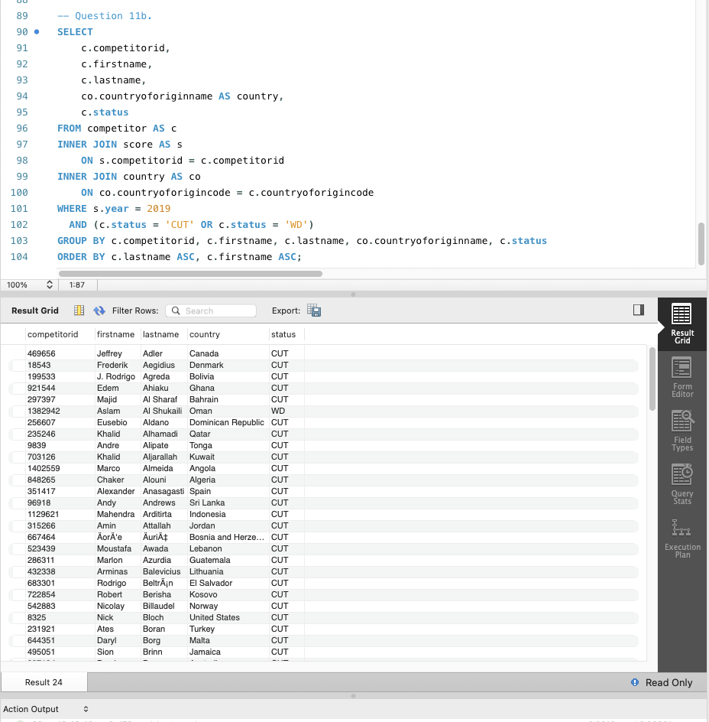

- Show the total points earned by country, with the highest total points showing first. Show the population for each country also.
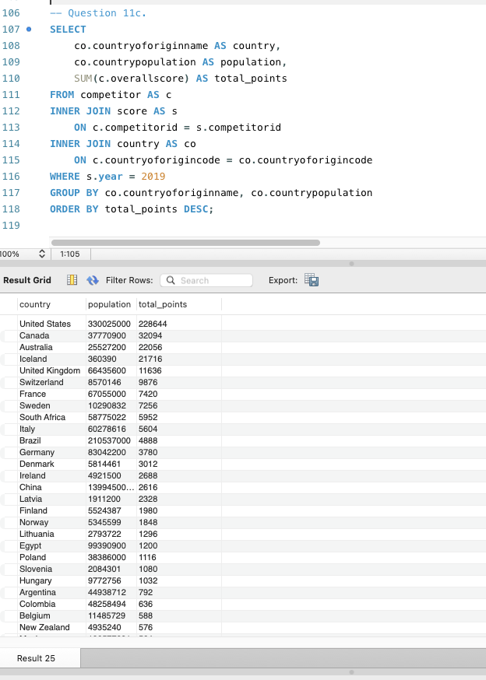

- Who are the ten best athletes in the Men (35-39) Division in terms of overall score?
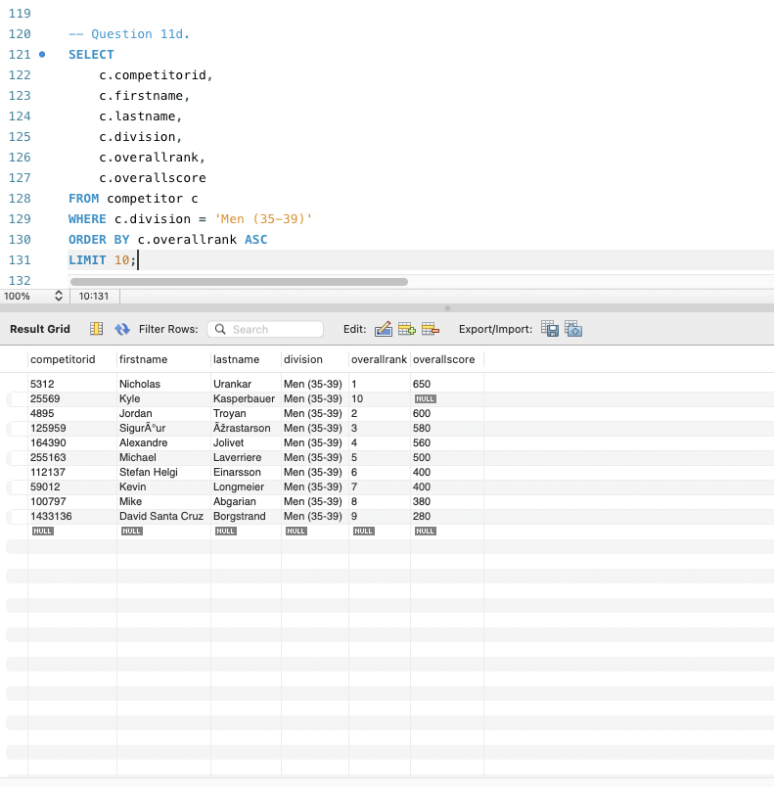

- Who are the athletes from countries whose country names end in land? Use REGEXP to filter the data.
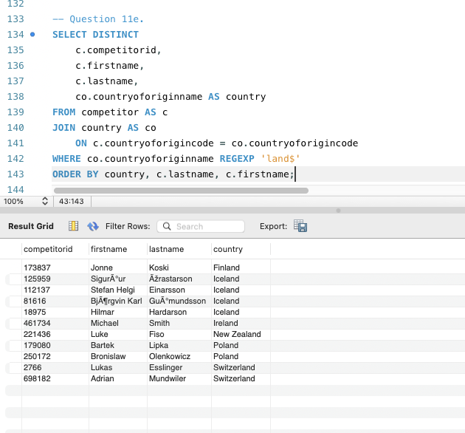

- Create one additional SQL program to answer a question not already asked. It must join three of the tables in your design. Q- Which division had the most competitors from each country in 2019?
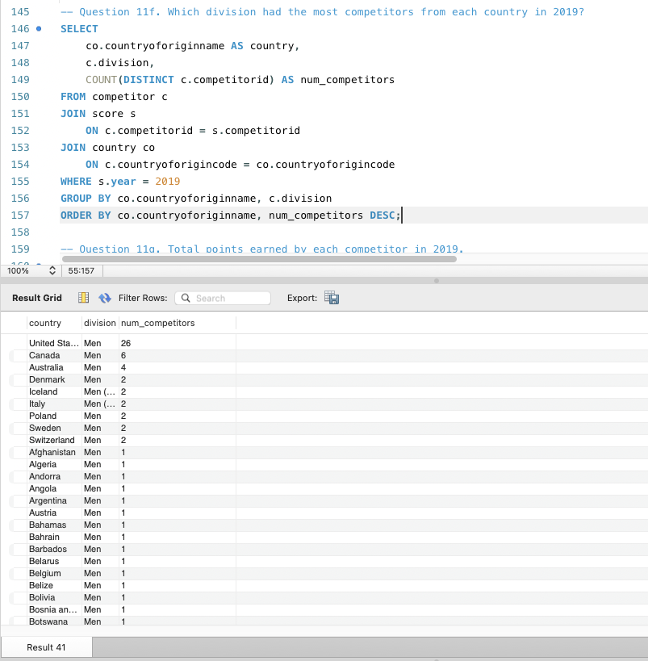

- Create one additional SQL program to answer a question not already asked. It must join at least two of the tables in your design and show aggregation. Q – what are the total points earned by each competitor in 2019?
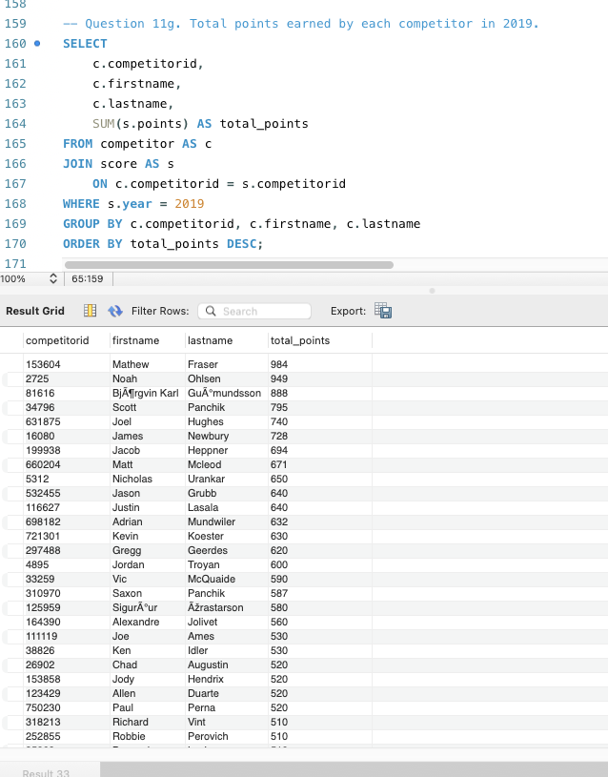

- Create one additional SQL program to answer a question not already asked. It must contain a subquery. Q - Which competitors scored the lowest points in any event in 2019?
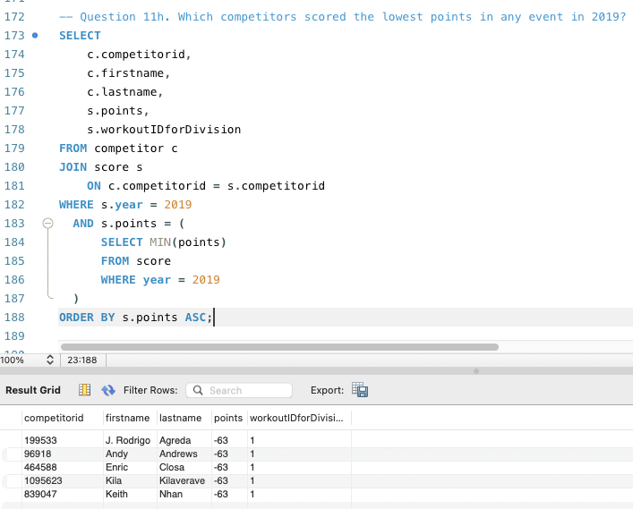

- Create one additional SQL program to answer a question not already asked. It must be filtered using the LIKE statement. Q - Which competitors have a last name that starts with the letter ‘J’ in 2019?
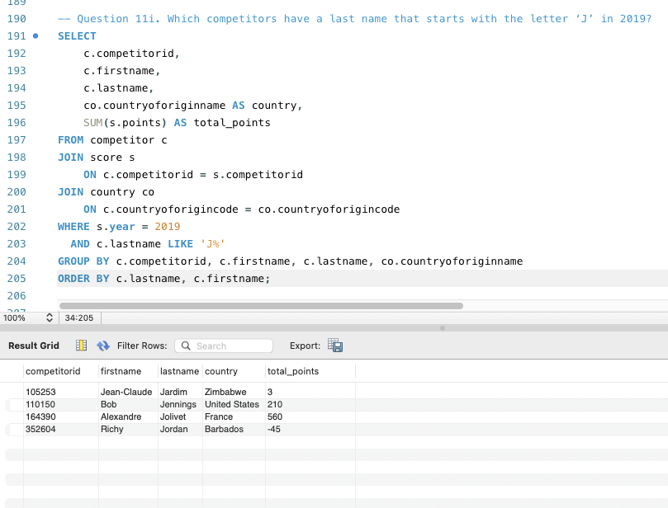

Submit the following to Moodle by the deadline:
- This word document (with screenshots for each step from 7-11i); and
- the .sql file.

